­­­­­­­______________________________________________________________________

**CYBERSECURITY PROJECT**

**PROJECT TITLE: INCIDENT RESPONSE AND AUTOMATION**

**VERSION:Commercial/User Edition**

**DATE CREATED:02-01-2025**

**Table of content:**

|  |  |  |
| --- | --- | --- |
| **S.NO** | **Name Of The Topic** | **Page Number** |
| 1. | Project Abstract | 02-03 |
| 2. | Project Scope   * Objectives * Requirements * Environmental Setup | 03-07 |
| 3. | Project Problem | 07-08 |
| 4. | Project Solution | 09 |
| 5. | Implementation   * Installation of Virtualbox * Monitoring Logs * Installation of Splunk * Installation of Owasp Juice-Shop * Installation of zaproxy | 10-28 |
| 6. | Conclusion | 29-30 |

**Project Abstract**

This project serves as an educational platform for individuals to gain practical experience in web application security and incident response. By leveraging the OWASP Juice Shop—a deliberately vulnerable web application—participants will engage in a series of exercises to simulate real-world scenarios in cybersecurity.

The project’s main objectives include setting up the environment, deploying the application, monitoring security events, simulating attacks, detecting incidents, and developing a structured incident response process.

### **Objectives**

* Setting Up a Secure Environment
  + Create a secure and isolated environment using VirtualBox. This ensures that all activities, including vulnerability exploitation and security testing, are contained within a sandboxed setup, preventing any unintended impact on other systems.
  + Utilize Kali Linux 2024.3, a security-focused operating system, to serve as the testing platform. Kali Linux comes preloaded with an array of penetration testing tools that are invaluable for this project.
* Deploying the Application
  + Install and configure the OWASP Juice Shop web application within the environment. This application is designed to demonstrate common security vulnerabilities, providing a safe space for hands-on experimentation.
  + Configure the application to log security events and interactions for analysis.
* Monitoring for Security Events
  + Set up the ELK Stack (Elasticsearch, Logstash, Kibana) to collect, process, and visualize logs generated by the Juice Shop application.
    - Elasticsearch stores the logs for quick retrieval and analysis.
    - Logstash processes incoming logs, standardizes formats, and enriches data for actionable insights.
    - Kibana offers a graphical interface to visualize trends, anomalies, and potential security events.
* Simulating Attacks and Detecting Incidents
  + Use tools such as Nmap and OWASP ZAP to simulate network scanning, vulnerability discovery, and exploitation of the Juice Shop application.
    - Nmap identifies open ports, running services, and potential entry points in the application.
    - OWASP ZAP performs web application vulnerability scans, detecting issues such as SQL injection, XSS (Cross-Site Scripting), and insecure configurations.
  + Enable ModSecurity as a Web Application Firewall (WAF) to detect and log malicious activity. ModSecurity helps mitigate attacks by blocking known patterns and providing detailed logs.
* Developing an Incident Response Process
  + Analyze logs and alerts generated during simulated attacks using Kibana dashboards.
  + Document steps to identify, contain, and mitigate the detected incidents.
  + Develop a comprehensive incident response process, including:
    - Initial detection and validation.
    - Containment of the attack.
    - Eradication of the threat.
    - Recovery of the application.
    - Post-incident review to enhance future defenses.

**Project Scope**

### **1. Objectives**

The primary goal of this project is to provide hands-on experience in key areas of cybersecurity, particularly in **incident response** and **security automation**. The specific objectives are:

* Practical Incident Response: Learn to identify, analyze, and respond to security incidents in a controlled environment.
* Understanding Vulnerabilities and Web Security: Gain insights into common vulnerabilities, attack vectors, and best practices for securing web applications and systems.
* Log Analysis Skills: Develop the ability to collect, process, and analyze logs to detect suspicious activities and security events.
* Automation for Incident Response: Implement and test automated security monitoring and response mechanisms to enhance the speed and accuracy of incident handling.

### **2. Requirements**

The tools and systems required for this project are categorized into **software** and **operating systems**:

#### **Software**

VirtualBox:  
A virtualization tool to set up and run virtual machines (VMs) for testing and experimentation. VirtualBox allows creating isolated environments where various operating systems and servers can interact securely.

ELK Stack:

* + Elasticsearch: Stores logs and facilitates quick search and retrieval of log data.
  + Logstash: Processes and enriches logs for structured analysis.
  + Kibana: Provides a user-friendly interface to visualize and analyze logs.

Incident Response and Vulnerability Scanning Tools:

* + Wireshark: For network traffic analysis.
  + Nmap: For network mapping and vulnerability scanning.
  + OWASP ZAP: For identifying vulnerabilities in web applications.
  + ModSecurity: To monitor and protect web applications.

#### **Operating Systems**

Kali Linux 2024.3:

* + A penetration-testing Linux distribution with pre-installed tools for forensics, vulnerability assessments, and incident response.

Windows Server:

* + Acts as a domain controller and file server to simulate enterprise-grade IT infrastructure.

Linux Server:

* + Hosts the web server and database server for running applications and storing data.

Windows 11:

* + Acts as client machines to simulate end-user interaction with the environment.

### **3. Environmental Setup**

The setup involves deploying multiple virtual machines (VMs) within VirtualBox to replicate an enterprise IT environment. Each VM will play a specific role, creating a realistic simulation for testing security practices and incident response workflows.

#### Virtual Machines Configuration

Forensics OS: Kali Linux 2024.3

* + **Purpose**:
    - Perform vulnerability scanning, penetration testing, and forensics.
    - Act as the primary machine for incident response activities.
  + **Roles:**
    - Investigate security incidents by analyzing logs and network traffic.
    - Exploit vulnerabilities in the target systems to understand risks.

Windows Server

* + **Purpose**:
    - Acts as a **Domain Controller** to manage user authentication and access.
    - Serves as a **File Server** for shared storage, simulating an enterprise setup.
  + **Roles**:
    - Simulate attack scenarios such as privilege escalation or unauthorized access.
    - Provide event logs for analysis.

**Linux Server**

* + Purpose:
    - Hosts critical applications and data to simulate production servers.
  + Components:
    - Web Server: Hosts a vulnerable web application, such as OWASP Juice Shop.
    - Database Server: Stores sensitive data to simulate real-world risks.
  + Roles:
    - Serve as targets for vulnerability scanning and simulated attacks.
    - Generate logs for incident detection and response activities.

Client Machines:Windows 11

* + Purpose:
    - Simulate end-user activities such as accessing web applications, downloading files, and authenticating with the domain.
  + Roles:
    - Act as sources of normal and malicious activity to test detection mechanisms.
    - Provide realistic traffic and behavior for monitoring.

### Additional Configuration Details

Networking

* + Set up an isolated virtual network in VirtualBox to interconnect the virtual machines securely.
  + Use NAT or Host-Only networking to allow controlled internet access if required.

Logging and Monitoring

* + Configure all servers and applications to forward logs to the **ELK Stack**.
  + Enable logging on the Windows Server (e.g., Windows Event Logs) and Linux Server (e.g., syslog).

Attack Simulation

* + Deploy tools like Nmap, Wireshark, and OWASP ZAP from the Kali Linux VM to simulate attacks.
  + Test WAF rules and incident detection capabilities using ModSecurity.

Automation

* + Use scripts or tools to automate repetitive tasks such as log collection, alert generation, and basic incident response actions.

### **Outcome**

By setting up and using this environment, participants will:

* Gain a thorough understanding of IT infrastructure components and their vulnerabilities.
* Learn to detect, analyze, and respond to security incidents effectively.
* Build practical skills in setting up and managing a security monitoring environment.
* Experience real-world scenarios for vulnerability scanning, log analysis, and incident response.

**Project Problem**

In today’s digital landscape, the rise of sophisticated cyber threats has made web application security a critical priority for organizations. Many web applications are vulnerable to a range of attacks that can have severe consequences, including:

* SQL Injection: Exploiting database queries to manipulate or access sensitive information.
* Cross-Site Scripting (XSS): Injecting malicious scripts to compromise user sessions or steal data.
* Cross-Site Request Forgery (CSRF): Forcing users to execute unwanted actions on authenticated sessions.

These vulnerabilities can lead to:

* Data Breaches: Exposure of sensitive information.
* Unauthorized Access: Compromise of systems and user accounts.
* Financial Losses: Direct and indirect costs associated with remediation, fines, and reputational damage.

Despite the availability of advanced security tools and frameworks, a significant challenge persists:

* Many cybersecurity professionals, especially beginners, lack practical knowledge and hands-on experience.
* This gap hinders the effective identification and mitigation of vulnerabilities in real-world scenarios.

As cyber threats continue to evolve, bridging the gap between theoretical knowledge and practical application is crucial. Empowering professionals with the skills and tools to safeguard web applications is a vital step toward strengthening organizational security.

**Project Solution**

This project aims to address the following key problems:

**1. Lack of Practical Experience:**

* Many cybersecurity beginners lack hands-on experience with real-world web application security tools and techniques.
* There is a need for an educational platform that provides a safe and controlled environment to practice these skills.

**2. Inadequate Incident Response:**

* Organizations often struggle with developing effective incident response plans and playbooks.
* There is a need to simulate and practice incident detection and response to improve readiness for actual security incidents.

**3. Difficulty in Monitoring and Analysis:**

* Monitoring web applications for security events and analyzing logs can be challenging without the right tools and configurations.
* Implementing comprehensive logging and monitoring systems is crucial for effective incident detection and response.

**4. Understanding of Web Vulnerabilities:**

* Beginners need to understand common web vulnerabilities and how to exploit them to better defend against real-world attacks.
* There is a need for structured learning that includes both vulnerability assessment and practical attack simulation.

**Installation of Kali Linux in Virtual Box:**

**Step 1:** Installation of Kali Linux on Virtualbox

<https://kali.download/base-images/kali-2024.3/kali-linux-2024.3-virtualbox-amd64.7z>

**Step 2:** Configuration of Kali Linux on Virtualbox

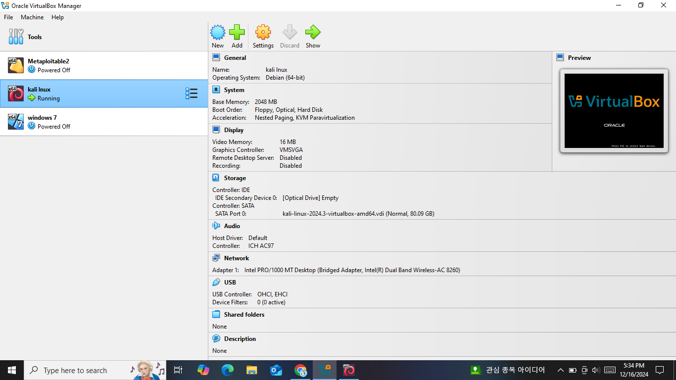

**Monitoring Logs:**

**Step 1:**

* Need to install splunk
* Opening the Splunk in the Local host
* Local Host port number:8000
* Home Page of the Splunk has been Loaded

Steps to install splunk:

* sudo /opt/splunk/bin/splunk start

Purpose: Starts the Splunk service.

What it does:

* Runs Splunk from its installation directory, located at /opt/splunk/bin/.
* The sudo command ensures administrative privileges are used, as starting Splunk often requires elevated permissions.
* During the first run, you may be prompted to accept the Splunk license agreement and set an admin username and password.

Result: The Splunk service starts, allowing you to access it via the web interface (http://localhost:8000).

* ls -l

Purpose: Lists files and directories in the current working directory with detailed information.

What it does:

* + Displays contents in a long listing format.
  + Provides details like file permissions, ownership, size, and last modification date.

Useful for: Checking the attributes of files, such as ensuring that splunk-9.4.0-6b4ebe426ca6-linux-amd64.deb is present and has the appropriate permissions.

* sudo dpkg -i splunk-9.4.0-6b4ebe426ca6-linux-amd64.deb

Purpose: Installs the Splunk .deb package on your Linux system.

What it does:

* + The dpkg -i command installs the specified .deb package.
  + splunk-9.4.0-6b4ebe426ca6-linux-amd64.deb is the package file for Splunk Enterprise version 9.4.0.
  + The sudo command ensures you have the necessary permissions to install system software.

Result: The Splunk application is installed, typically in the /opt/splunk directory.

* ls /opt

Purpose: Lists the contents of the /opt directory.

What it does:

* Displays all files and directories inside /opt, which is often used for optional or third-party software installations.
* Verifies that the splunk directory exists, confirming that Splunk has been successfully installed.
* sudo /opt/splunk/bin/splunk start

Purpose: Starts the Splunk service again after installation.

What it does:

* Ensures that the Splunk service is running and ready to use.
* Since the command was used earlier, it might now skip initial setup prompts and directly start the service.

Step1:

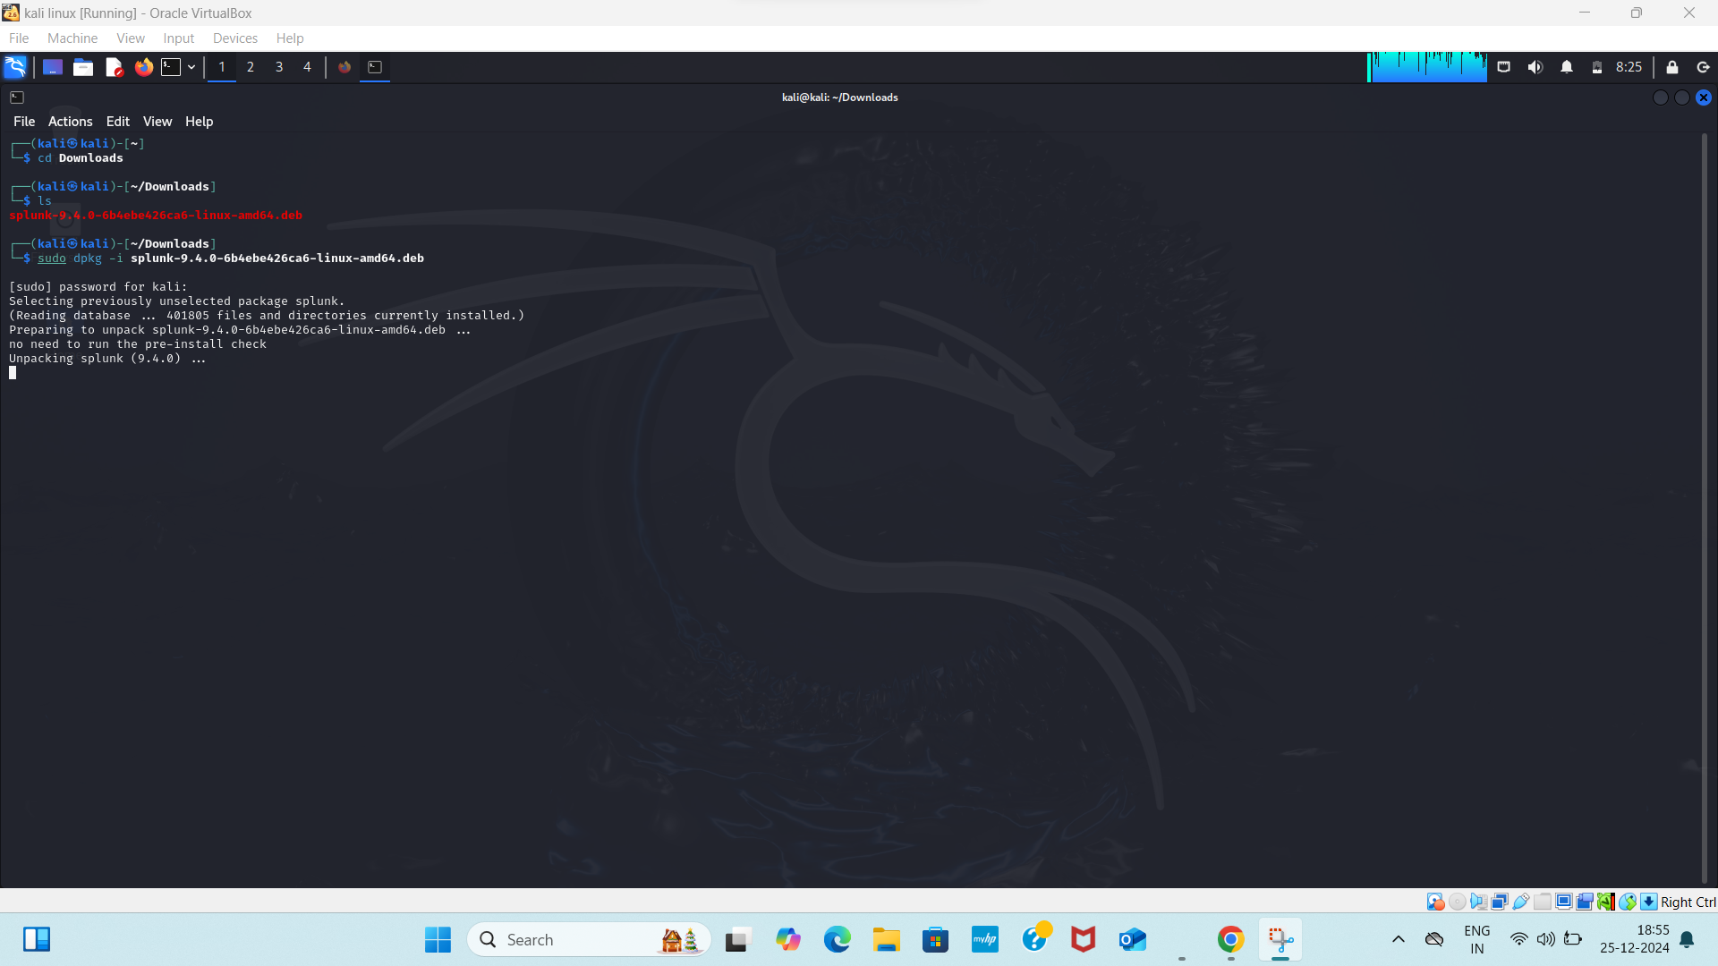

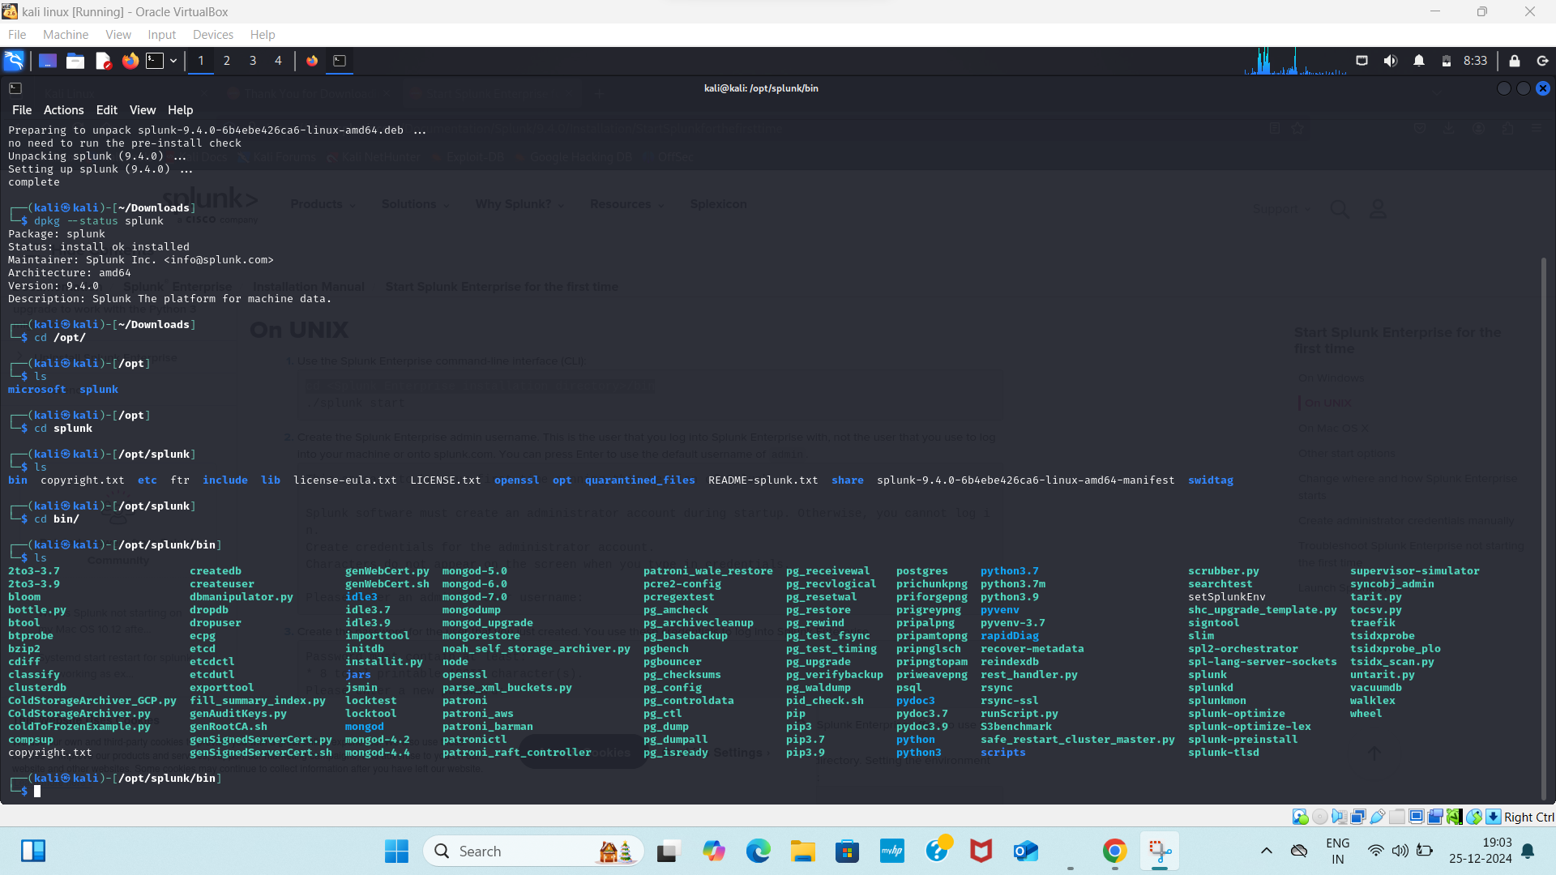

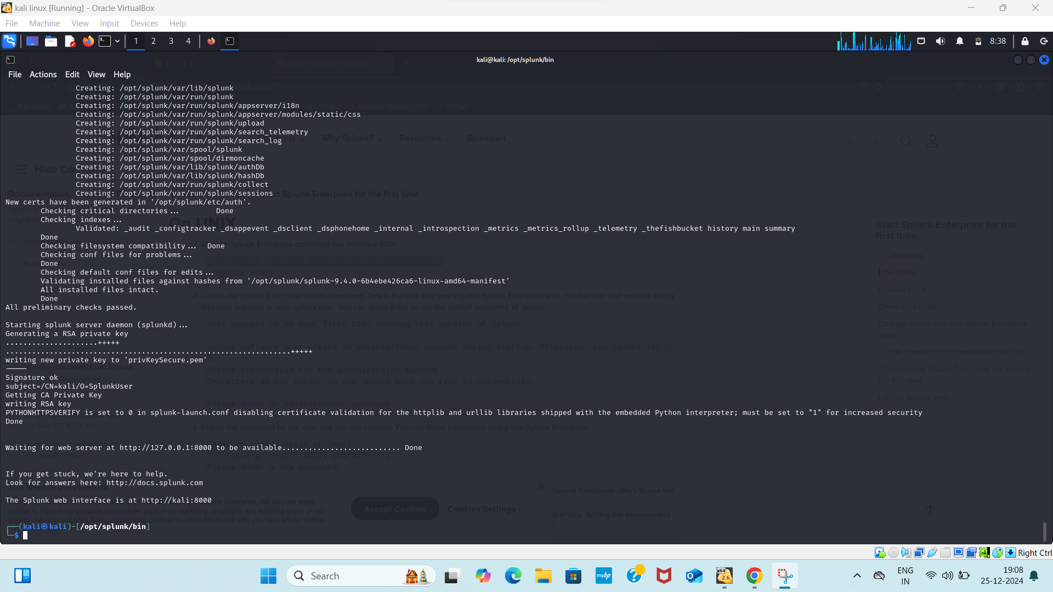

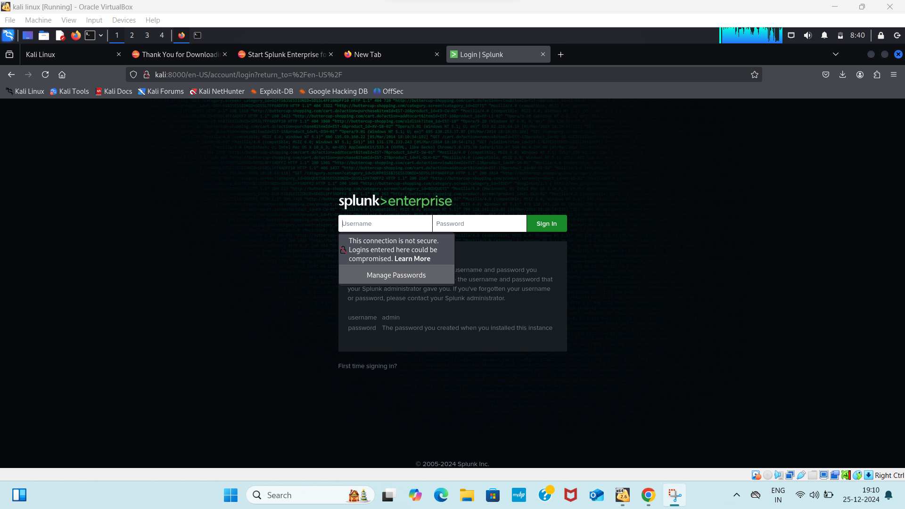

**Step2:**

* Open the settings in the top Right corner
* Select the Data Input

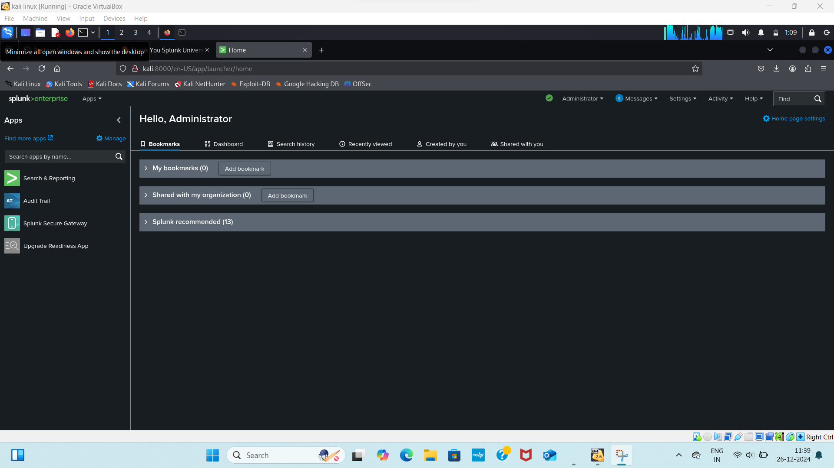

**Step3:**

* In Data Input there will some Local Input
* In which select the http event collector
* Http event is used to collect the logs from the Owasp Juice Shop

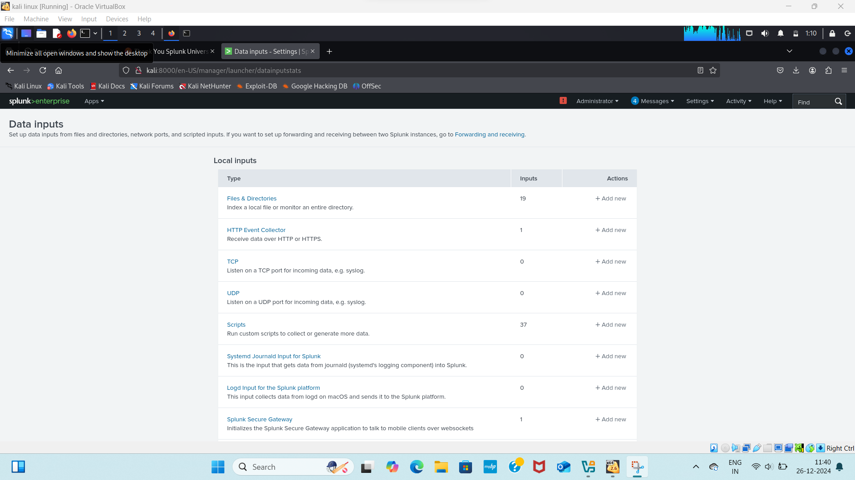

**Step4:**

* After Opening the Http event collector there will option to add the “New token”
* New token is used for indicating the token id which the logs from website will allocated with the “New token”

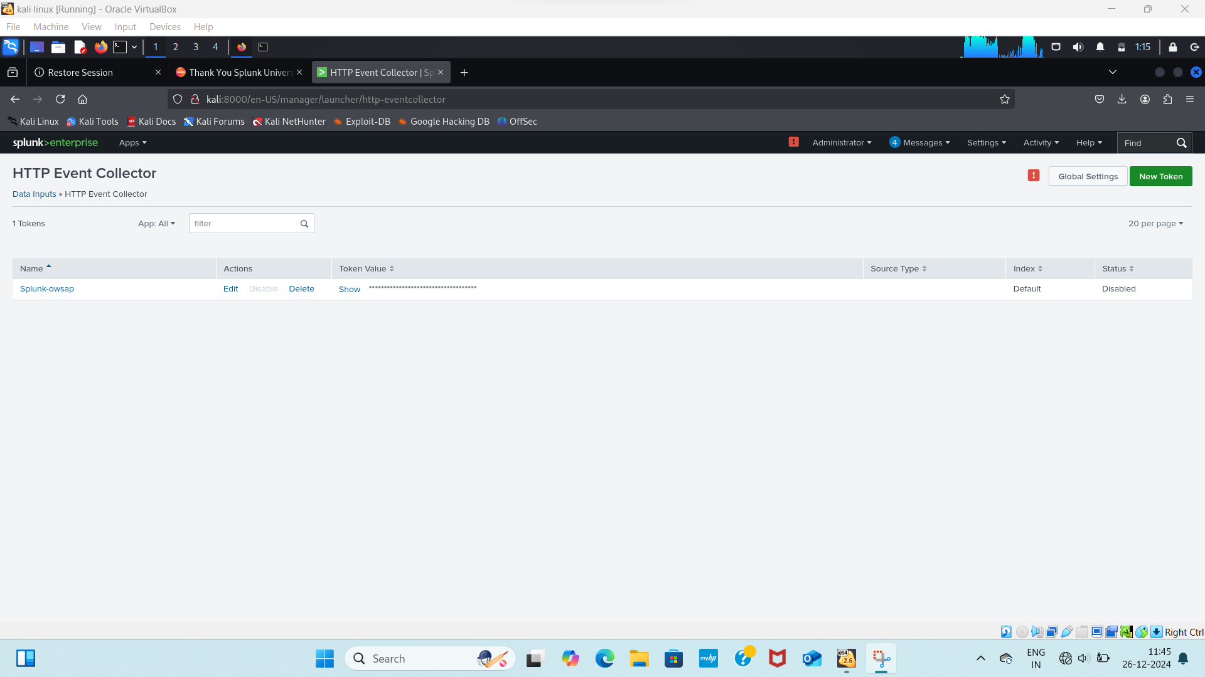

Process for creating an token and Add Data

**Step5:**

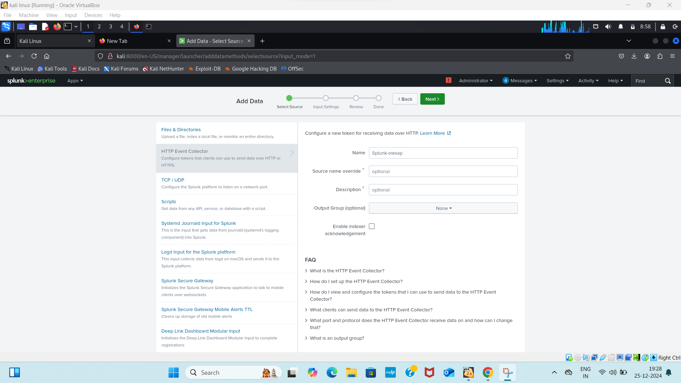

**Step6:** Review

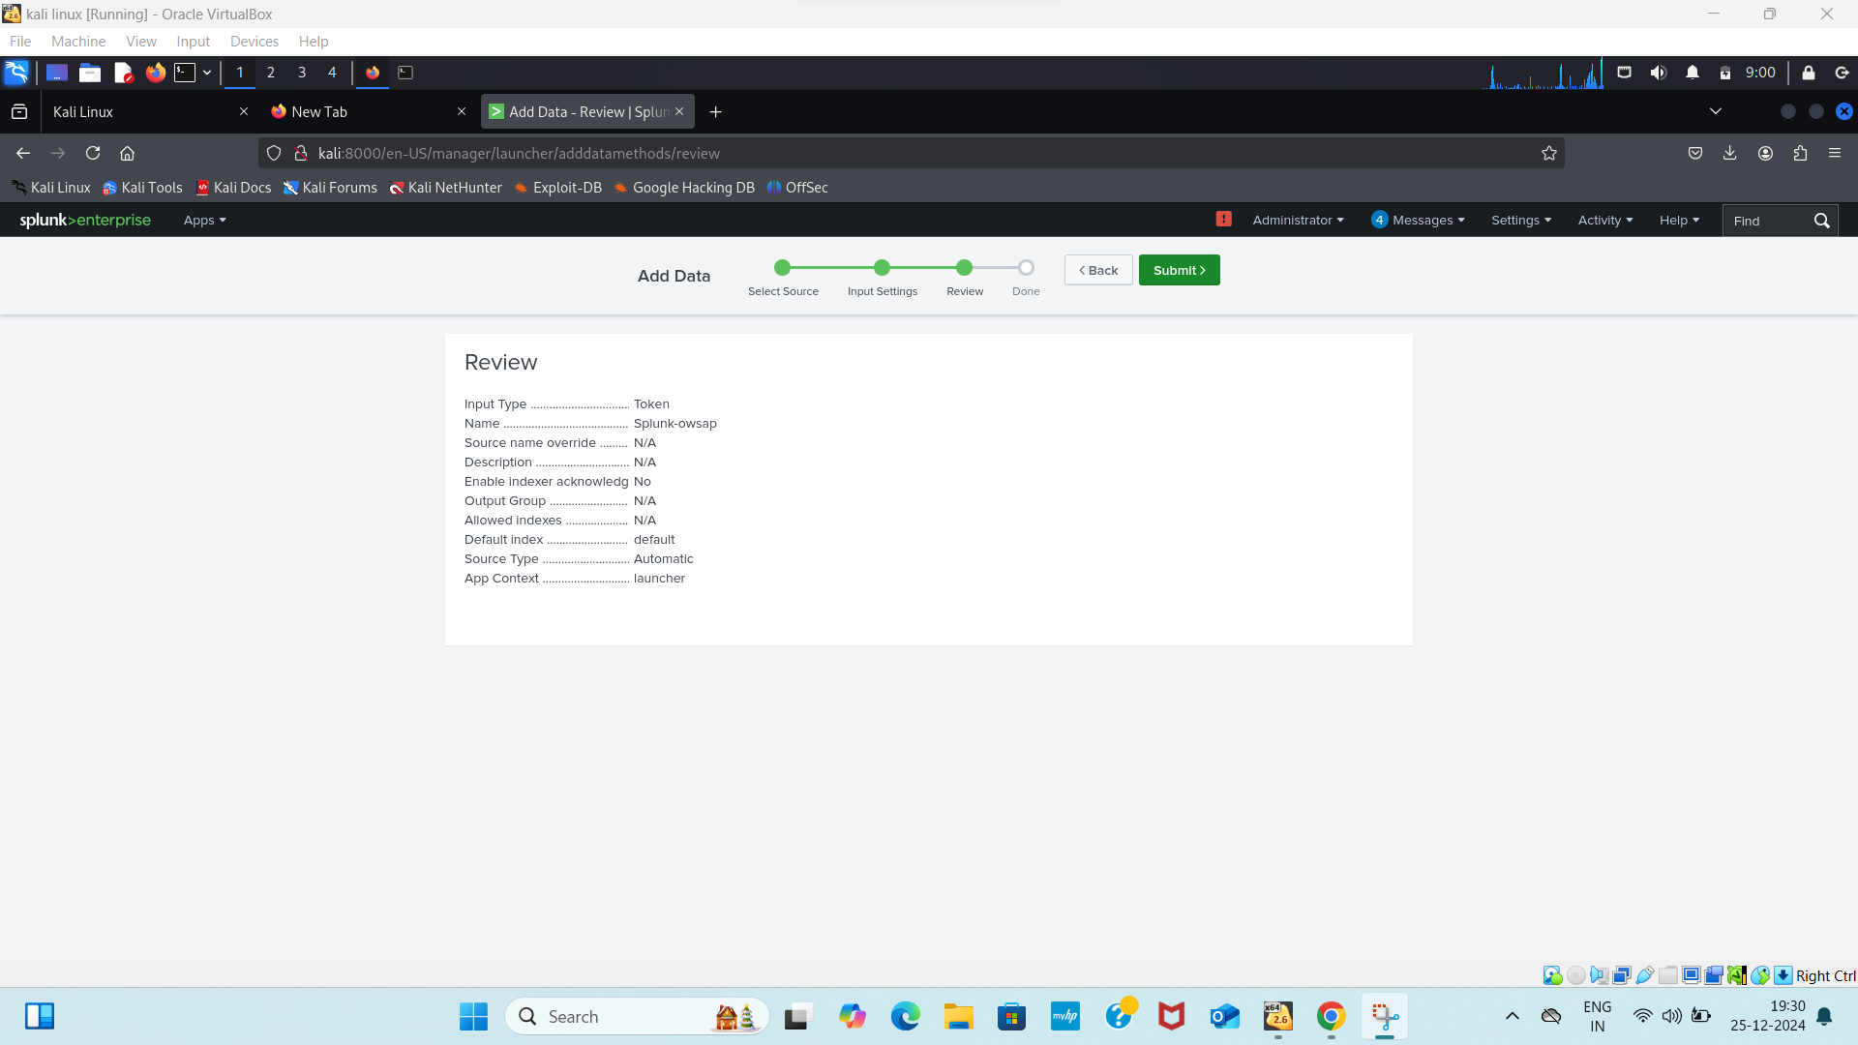

**Step7:**

* Token has been created Successfully

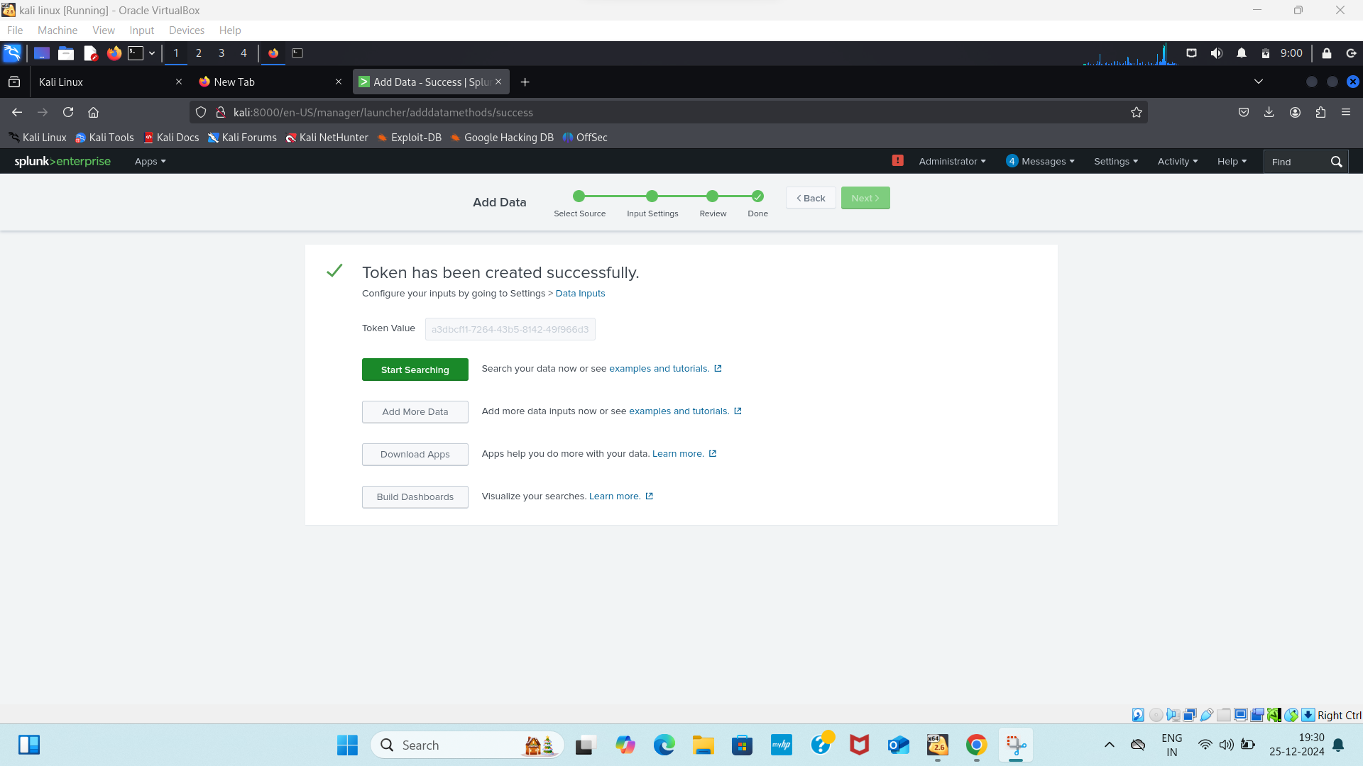

Steps to download OWASP juice-shop Application:

OWASP Juice Shop is an intentionally vulnerable web application for security training.

#### **Steps:**

Install Node.js and npm: Juice Shop requires Node.js. Install it with the following commands:

* sudo apt update

Purpose: Updates the package list of your system.

What it does:  
This command retrieves the latest package lists from the repositories configured on your system. It ensures that you get the most recent versions of packages and dependencies when installing or upgrading software.

* tar -xvzf juice-shop_17.1.1

**purpose:** Extracts the contents of the juice-shop_17.1.1 tarball file.

Options explained:

-x: Extract the files from the tarball.

-v: Verbose mode, shows the progress and lists the files being extracted.

-z: Specifies that the tarball is compressed with gzip.

-f: Indicates the name of the file to process.

What it does:  
This command extracts the juice-shop_17.1.1 tarball into the current directory. The extracted folder will contain the source files for OWASP Juice Shop.

* sudo apt-get install nodejs

Purpose: Installs Node.js, a JavaScript runtime environment.

What it does:  
This command downloads and installs Node.js, which is required to run JavaScript code on the server-side, such as the Juice Shop application.

* sudo apt-get install npm

Purpose: Installs npm (Node Package Manager), a tool for managing Node.js packages.

What it does:  
npm is essential for downloading and managing dependencies for Node.js projects. Juice Shop relies on several Node.js libraries and frameworks that are managed through npm.

* cd juice-shop_17.1.1

Purpose: Changes the current directory to the extracted Juice Shop folder.

What it does:  
This moves your terminal session into the juice-shop_17.1.1 directory, where the application's source code and dependencies are located. All subsequent commands will be executed relative to this directory.

* pwd

Purpose: Prints the current working directory.

What it does:This displays the full path of the directory you are currently in. In this case, it shows the path to the juice-shop_17.1.1 directory, helping you confirm the location of the application files.

* npm start

Purpose: Starts the Juice Shop application.

What it does:  
This command:Looks for a script named start defined in the package.json file of the Juice Shop project.

Executes that script to start the application. By default, this will start a server on port 3000, making Juice Shop available at <http://localhost:3000>.

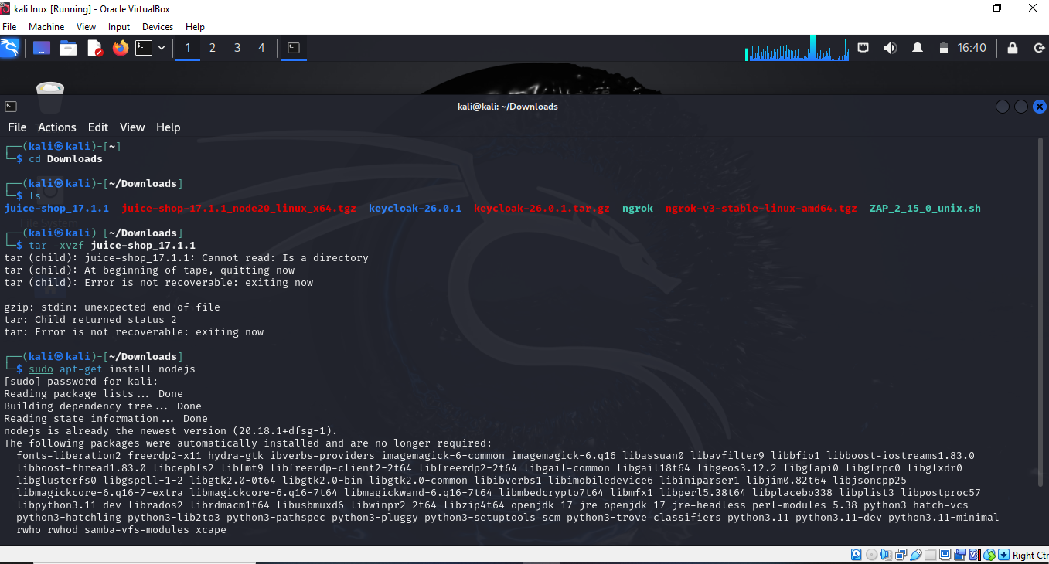

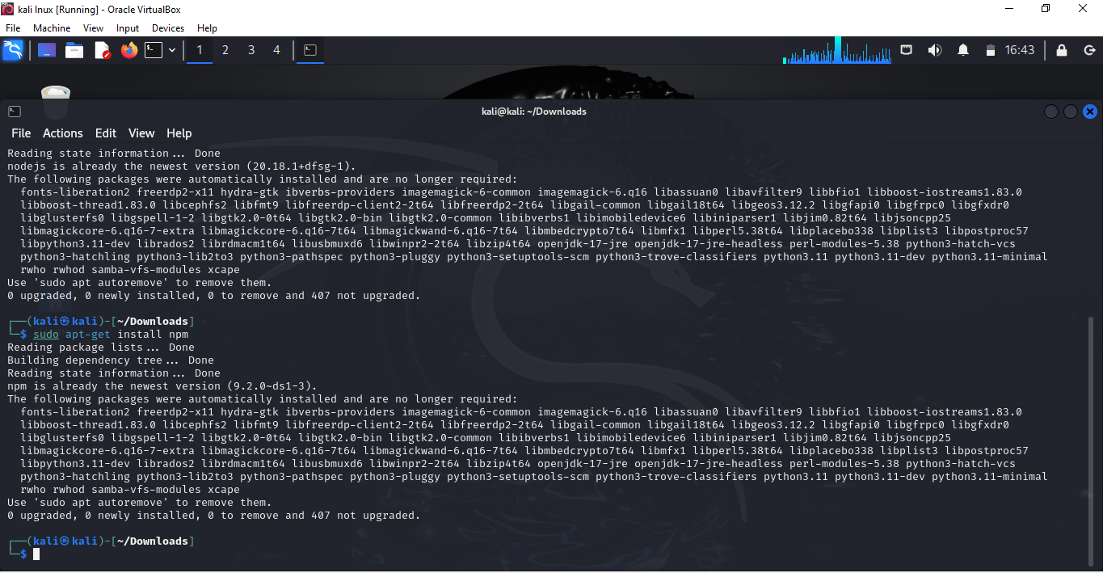

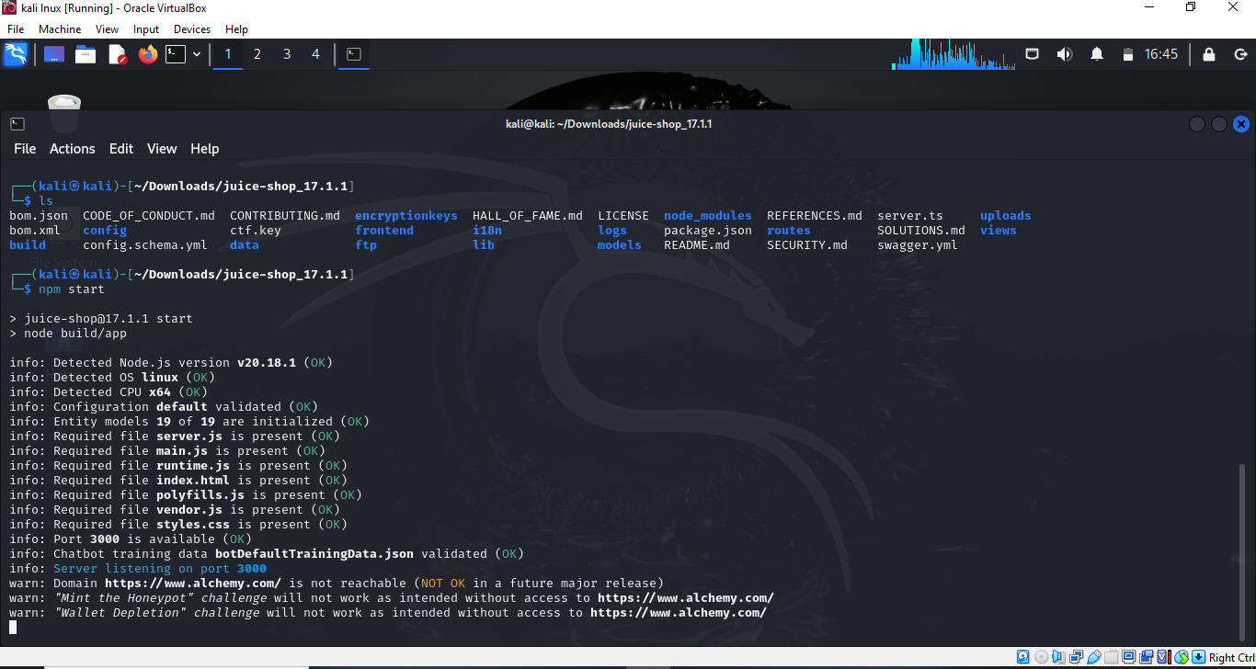

**Step8:**

* Login credentials

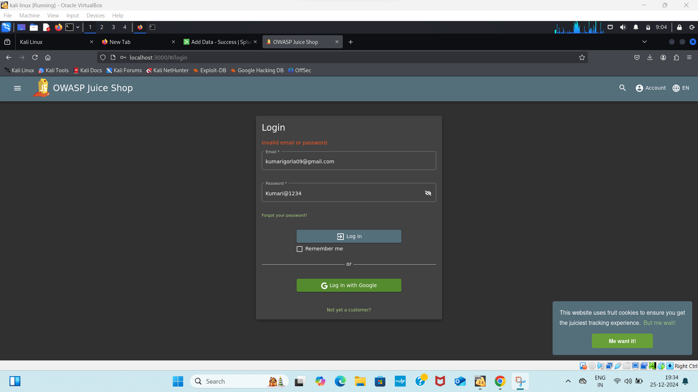

* Above image is the owasp juice shop login page where after entering the login credentials it will send the logs to splunk and we need to address the log in the splunk
* Need to check the log in the splunk and we need to check the alterusing the automatic scanner tool which is “Zaproxy”.
* The log will be monitored through splunk

**Step9:**

Accessing the log file

* Below image is the log source get collected in the splunk after entering the login credentials
* The logs are stored in the access.log file
* Cat command is used to see the access.log file

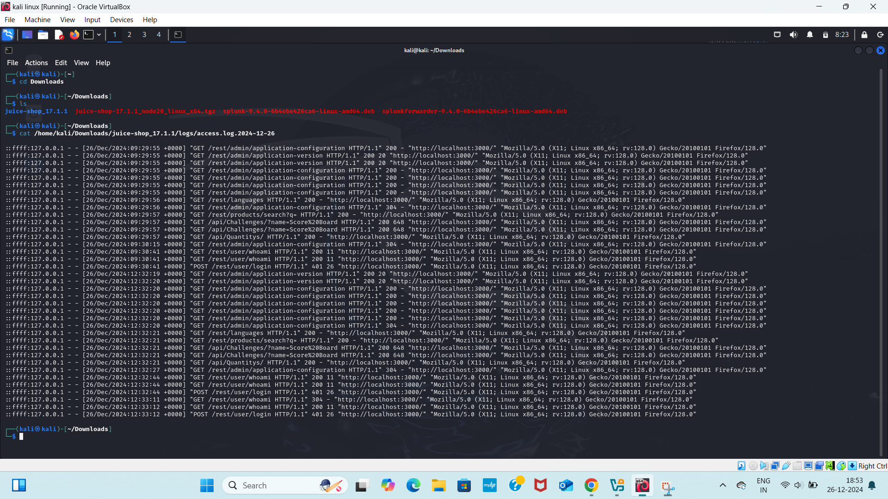

**Step10:**

* Checking the log in the splunk
* Monitor and configure the log in the splunk

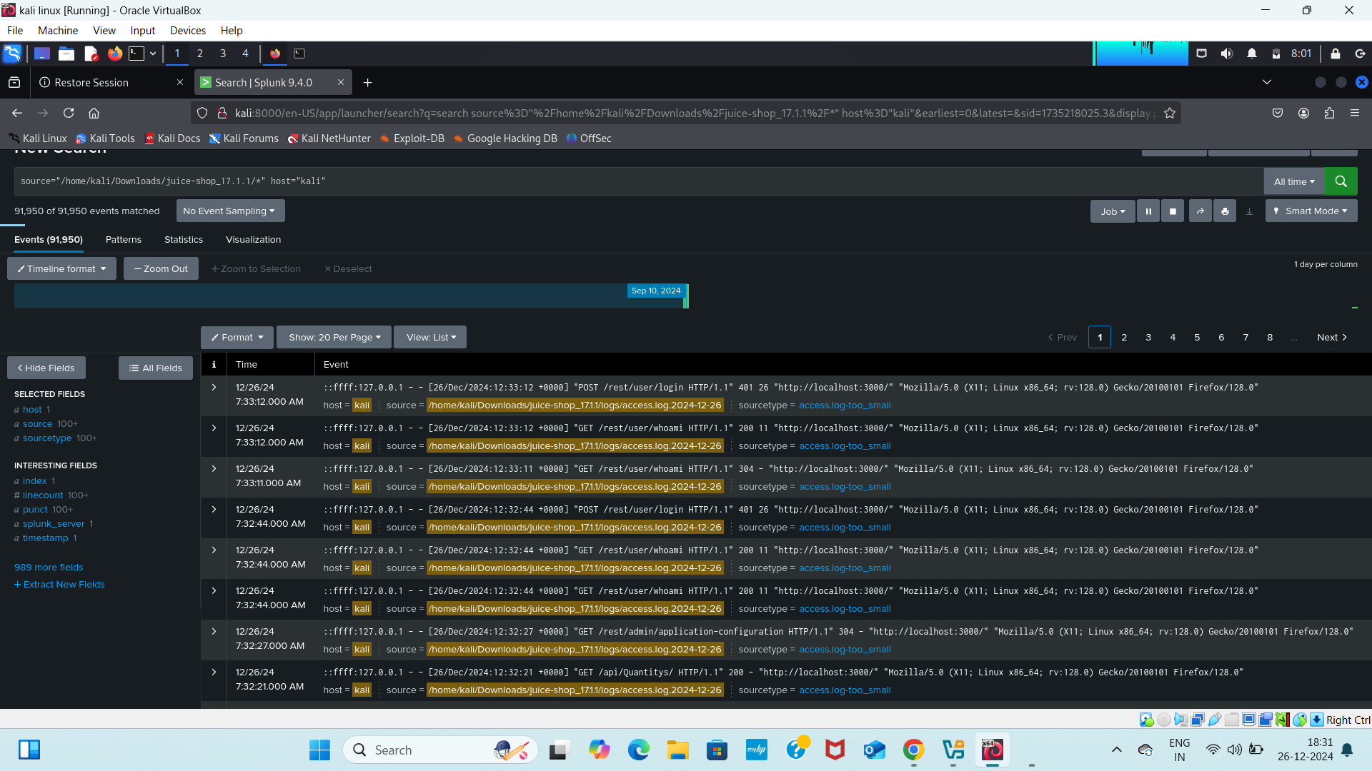

* The above is Http Event collector where we are able to see all the logs including the timestamp when the log has been loaded etc..
* Thus the successful configuration and monitoring of the logs in the splunk

**Installation of Zaproxy:**

* OWASP Zed Attack Proxy (ZAP) is an open-source web application security scanner and penetration testing tool developed by the Open Web Application Security Project (OWASP). It is designed to find security vulnerabilities in web applications and services.

Commands to install Zaproxy:

* cd Downloads

Purpose: Changes the current working directory to the Downloads folder.

What it does:

* + The cd command (short for "change directory") moves your terminal session into the Downloads directory.
  + This directory typically contains files downloaded from the internet, such as the ZAP_2_15_0_unix.sh file.
* ls

Purpose: Lists the contents of the current directory.

What it does:

The ls command displays all files and folders in the Downloads directory.

This helps confirm that the ZAP_2_15_0_unix.sh file is present in the directory.

* chmod +x ZAP_2_15_0_unix.sh

Purpose: Makes the ZAP_2_15_0_unix.sh file executable.

What it does:

* + The chmod command modifies the permissions of a file.
  + The +x option gives the file executable permission, allowing it to be run as a script or program.
  + Without this step, attempting to execute the file might result in a "Permission denied" error.
* ./ZAP_2_15_0_unix.sh

Purpose: Executes the ZAP_2_15_0_unix.sh installation script.

What it does:

* + The ./ tells the shell to execute the script from the current directory (not from the system's PATH).
  + This script is the installer for OWASP ZAP (Zed Attack Proxy) version 2.15.0.
  + Running the script initiates the installation or setup process for ZAP on your system.

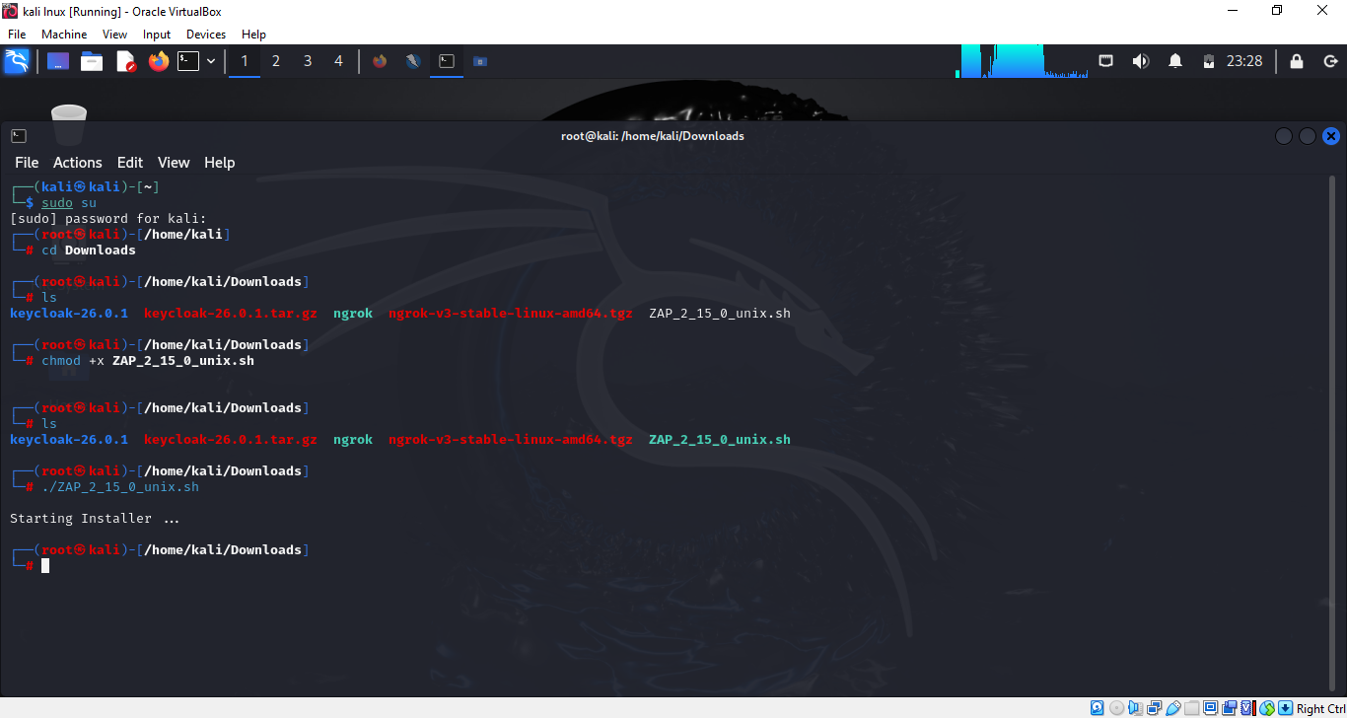

* **Interception Proxy**: ZAP can intercept and inspect HTTP and HTTPS traffic between the browser and the web application, allowing testers to see and modify requests and responses.
* **Automated Scanner**: ZAP includes automated scanners that can crawl a web application and test for common vulnerabilities, such as SQL injection, Cross-Site Scripting (XSS), and Cross-Site Request Forgery (CSRF).
* **Manual Testing Tools**: ZAP offers various tools for manual security testing, including a request editor, an active scanner, a spider for crawling, and a Fuzzer for exploring input fields.

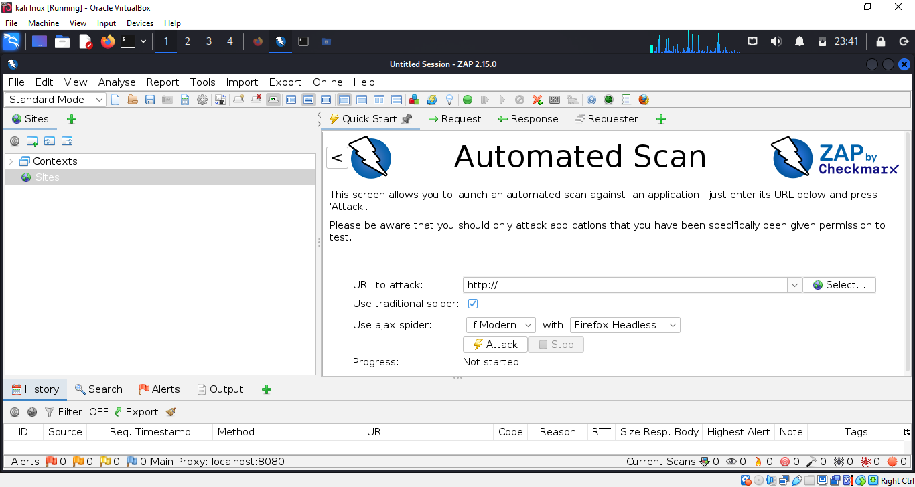

Step by Step process for Vulnerability Scanning:

Install and Launch ZAP:

* Ensure ZAP is installed and then launch the application.

Configure ZAP to Proxy Traffic:

* Set up your browser to use ZAP as a proxy (default:

localhost:8080).

* Configure SSL settings in your browser to accept ZAP’s root CA certificate if you need to intercept HTTPS traffic.

Start ZAP:

* Open ZAP and make sure it's running.

Access Juice Shop through ZAP:

* In your browser, navigate to http://localhost:3000 with ZAP running as the proxy. This will allow ZAP to intercept and log the traffic.

Run Automated Scan:

* In ZAP, right-click on the site node (e.g.,http://localhost:3000) in the "Sites" tab.
* Select "Attack" > "Spider to discover content".
* After the spider completes, right-click on the site node again and select "Attack" > "Active Scan".

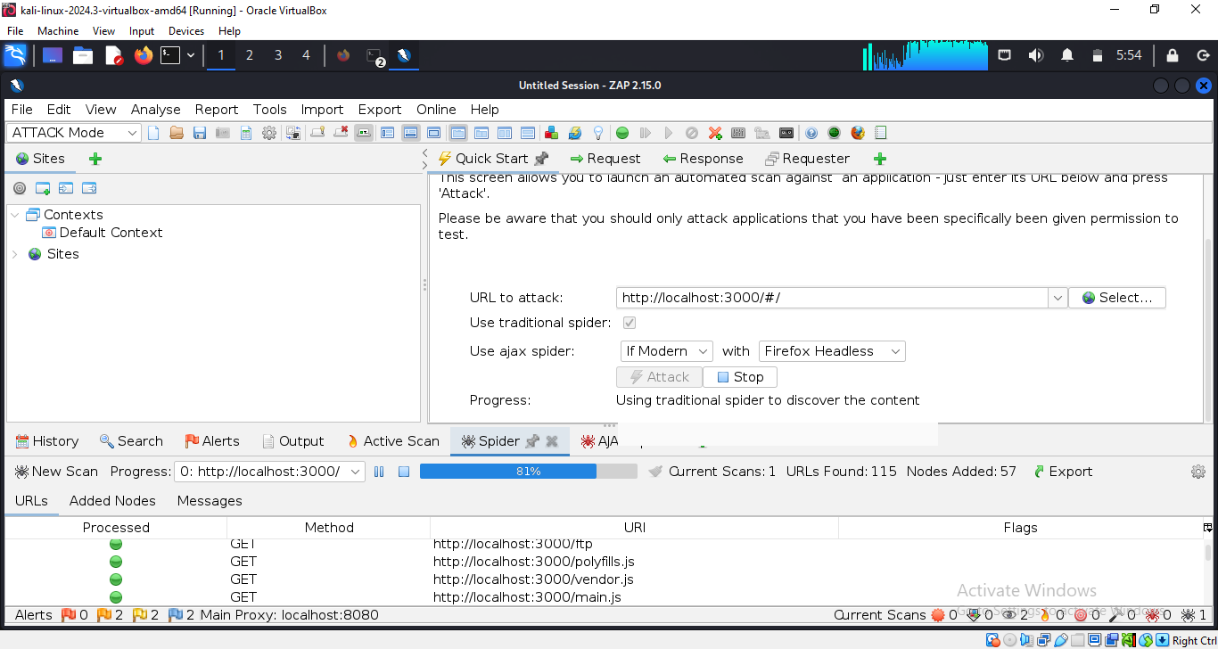

**Review Results**:

* Monitor the progress and results of the scan in the "Active Scan" tab.
* Analyze the identified vulnerabilities and issues reported by ZAP.

Reviewing the result by checking the high alerts:

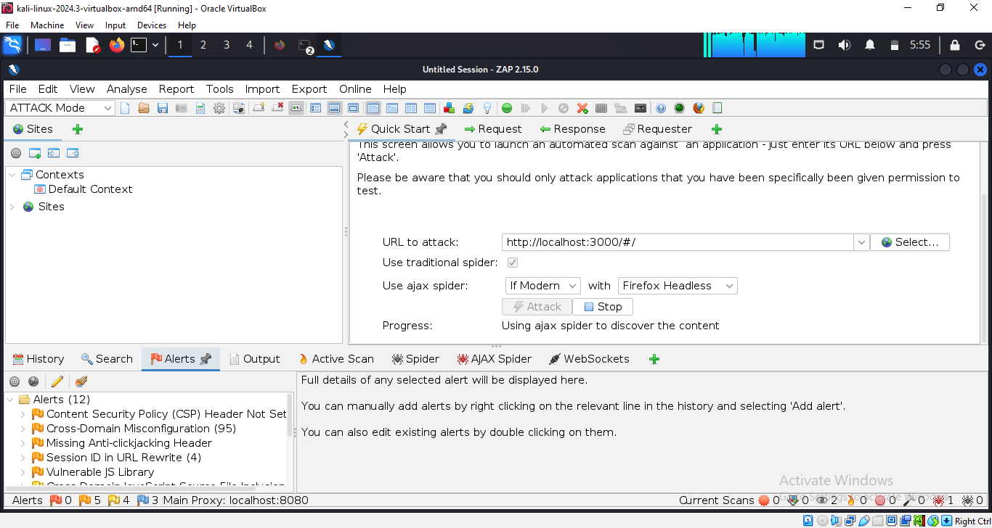

* The above image indicates the high vulnerabilities while Scanning using Zaproxy.

**Conclusion:**

Integration of Splunk and OWASP Juice Shop

This incident response and automation project demonstrates the effectiveness of integrating Splunk and OWASP Juice Shop for security testing and incident response.

* Splunk for Monitoring and Analysis: Splunk provides comprehensive monitoring and analysis capabilities, enabling valuable insights into security events and incidents. This enhances incident response capabilities by allowing for rapid identification and investigation of security issues.
* OWASP Juice Shop for Security Testing: OWASP Juice Shop, with its intentionally vulnerable design, serves as an ideal platform for testing and simulating various security scenarios. This allows for the evaluation and refinement of response strategies in a controlled environment.
* Benefits:  
  + Improved Security Posture: By actively testing and simulating security incidents, organizations can identify and address vulnerabilities proactively, improving their overall security posture.
  + Enhanced Incident Response Capabilities: The insights gained from Splunk analysis can significantly improve the speed and effectiveness of incident response.
  + Valuable Learning Experience: This approach provides a valuable learning experience in managing and automating security operations.

Key Takeaways:

* This project highlights the importance of advanced monitoring and analysis tools like Splunk in enhancing security operations.
* OWASP Juice Shop provides a valuable resource for security testing and training.
* The lessons learned and techniques developed in this project can serve as a foundation for future improvements in cybersecurity practices and automation.

**Note:** This is 100% of the project has been completed and reviewed by the trainer.

**Team Members:**

1. Katta Monika

2. Swamireddy Ramya

3. Gorla Lova Kumari